8th December 2017

Dear Parents,

We would like to inform you of a couple of festive events we have planned before the end of term.

**Friday 15th December – Christmas jumper day**

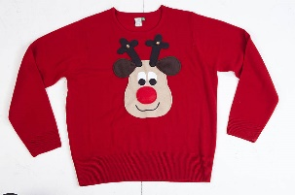As we are having our Christmas dinner next Friday, we thought it would be nice for the everyone to come to school wearing a Christmas jumper on this day. School trousers/skirts should still be worn. Please don’t go to any expense. If your child doesn’t have a jumper, they can wear a Christmas hat or “deely-boppers”.

**Carols around the Tree and Achievement Assembly**

**Tuesday 19th December 9.00 a.m.**

C:\Users\Janet Hernon\AppData\Local\Microsoft\Windows\Temporary Internet Files\Content.IE5\AD09857W\MC900140953[1].wmf

Come and join us for a festive sing along which will most definitely get you in the Christmas spirit. We will also be celebrating the children’s achievements during this assembly.

We would also like everyone to come dressed as a pantomime character on this day – “Oh yes we would!” Please make sure they dress as an authentic panto character e.g. Puss in Boots, Aladdin, Peter Pan, Cinderella, Snow White.

We hope you will be able to join us in school for the events we have organised.

Yours sincerely,

**A Ives**

Principal.