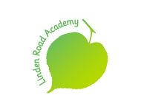

Thursday 14th November 2019
Dear Parents/Carers,
On Tuesday 19th November, our Y3 and Y4 classes will be taking part in a Samba drumming and dance workshop as part of our topic, ‘Amazing South America.’ This will be delivered by ‘Beat the Drum’ part of the Global Grooves cultural workshop charity. www.globalgrooves.org
Please make sure your child has their P.E kit on this day as they will need it for the whole morning.
School will be funding these workshops.
We are inviting you to come and watch a shared performance at approximately 11:45 am on the same day, which should last approximately 15 minutes.
Hope to see you there!
Thank you
J.Stephens, L.Hughes

