LINDEN ROAD ACADEMY

PRINCIPAL: MP. GREAVES TEL: 0161 320 0002

Dear Parents/Carers,

WORLD BOOK DAY – Thursday 7th March

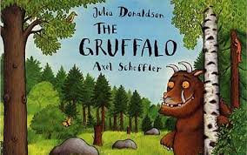
To celebrate World Book Day, we would like the children to come to school dressed as their favourite book characters on Thursday, 7th March. Costumes don’t have to be bought, they can be made using items from home. You have a whole week at half term to be creative and prepare an outfit! The whole school will be taking part in numerous reading activities throughout the day.

As in previous years, the children will be given a £1 book token, which they can exchange in all participating book shops. Look out for special displays and details of family based activities in local bookshops and libraries.

To find out more about World Book Day, please visit the website at www.worldbookday.com.

Please encourage your children and the whole family to get reading! We are looking forward to a successful and enjoyable day.

Yours sincerely,

Mr P. Greaves
Principal.

